**ROTATE LEFT OPERATION**

**EXP NO: 18**

**AIM:**To compute rotation of given data in left without carry using 8085 processor.

**ALGORITHM:**

1)  Load the base address of the array in HL register pair.

2  Move the data from memory location into accumulator.

3)  Shift left the accumulator content for four times.

4)   Store the result in the specified location.

**PROGRAM:**

MVI A,02

RLC

RLC

RLC

RLC

STA 2000

HLT

**INPUT:**

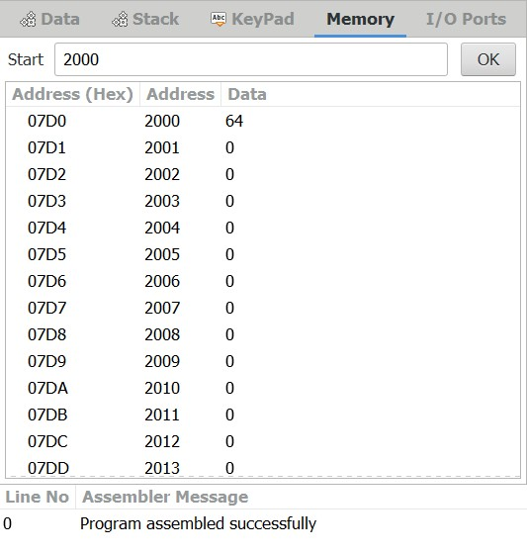

**OUTPUT:**

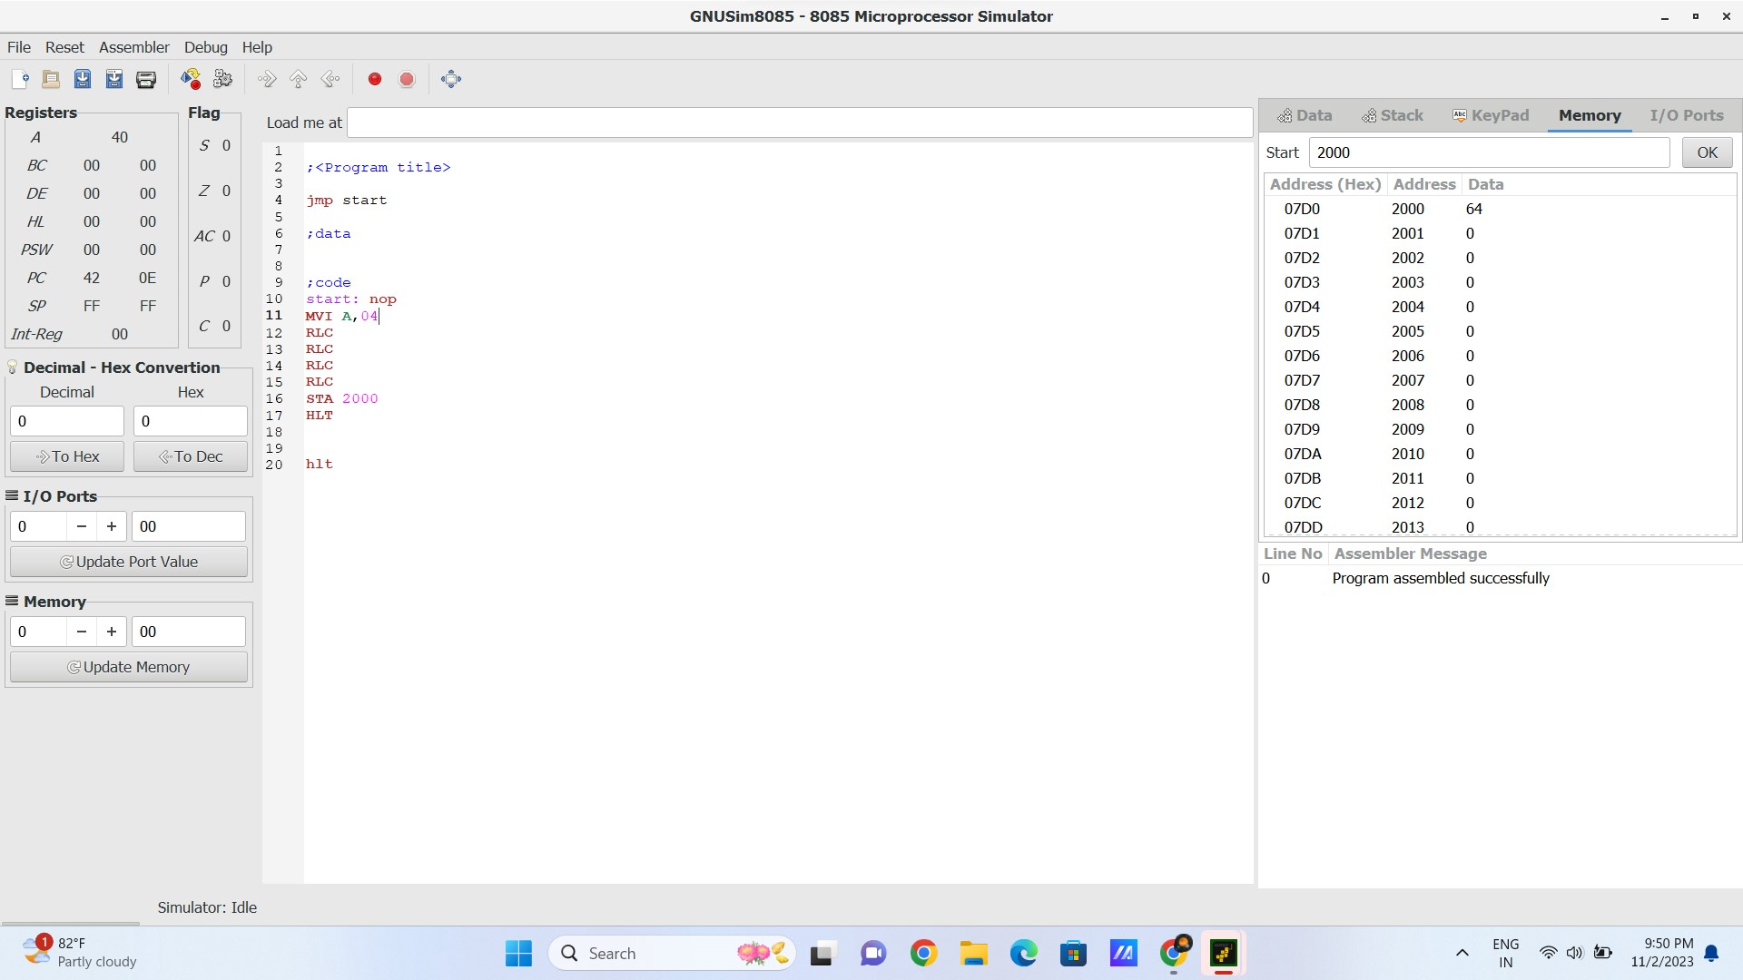  
  
  
**RESULT:**Thus the program was executed successfully using 8085 processor simulator.